Dear
You have worked hard to create all you have today. No doubt, you plan to take care of yourself and stay healthy. Suppose, just for a moment, that something unexpected were to happen to you and you were unable to earn your usual income for an extended period of time. Would you be able to manage financially?
You may believe that the likelihood of such an event happening to you is low, but did you know, more than one in four of today’s 20 year-olds will become disabled before reaching age 67?* And the average length of disabilities is increasing:
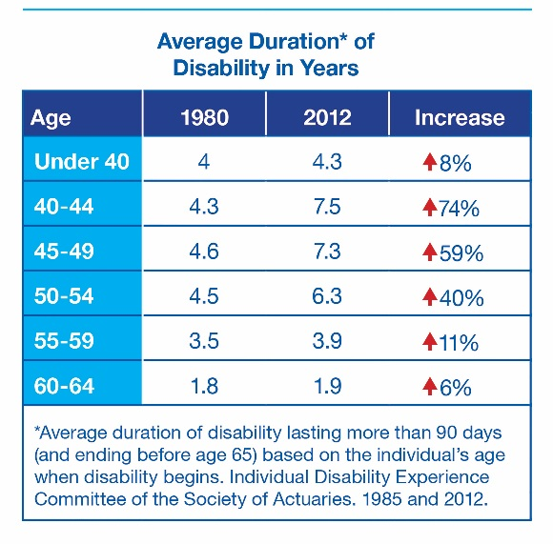
Fortunately, you can help protect yourself with individual disability income insurance from
The Standard‡. This coverage provides you with benefits you can use to help pay your bills when you are unable to generate your usual income due to a disabling illness or accident.
When you protect yourself against income loss, there is one more important element to consider: the insurance company you choose. The company should be financially stable so it will be there for you when you need it most. And when you do receive service, it should be expert and caring.
A leader in disability insurance, The Standard is financially stable and has been keeping its promises to customers since 1906. Known for its outstanding customer service, the goal of the friendly people at The Standard is to deliver the kind of service to you that they wish for themselves and their families.
I will contact you to answer any questions you may have about this essential protection from an outstanding company. Or if you prefer, you can reach me at >phone and/or email address<.

* Social Security Administration 2018 Fact Sheet. .

