Dear
You have worked hard to create all you have today. No doubt, you plan to take care of yourself and stay healthy. Suppose, just for a moment, that something unexpected were to happen to you and you were unable to earn your usual income for an extended period of time. Would you be able to manage financially?
You may believe that the likelihood of such an event happening to you is low, but did you know, more than one in four of today’s 20 year-olds will become disabled before reaching age 67?
And the average length of disabilities is increasing:
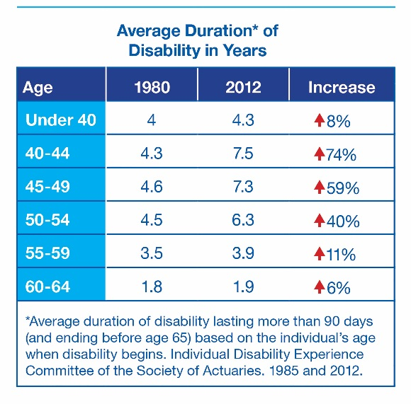
If you already have long term disability insurance through your employer, consider the difference between the coverage provided by long term disability benefits alone, and long term disability benefits plus individual disability income insurance, as shown in the charts below.2
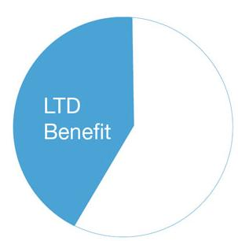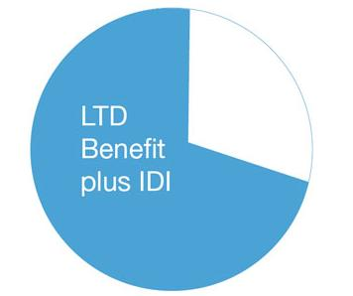
Don’t you owe it to yourself to take a look at individual disability income insurance? The more you earn, the more coverage you can apply for³. And in the event you decide to change jobs, as long as the premium is paid on time, your individual disability income insurance will continue to protect you against the unexpected.
I recommend individual disability income insurance from The Standard‡. A leader in disability insurance, The Standard is financially stable and has been keeping its promises to customers since 1906. Known for its outstanding customer service, the goal of the friendly people at The Standard is to deliver the kind of service to you that they wish for themselves and their families.
I would like to show you in more detail what your options are, and will contact you soon to answer any questions you may have about this important protection.
Sincerely,

3 Subject to The Standard’s issue and participation limits.

Social Security Administration 2018 Fact Sheet. 2 For illustrative purposes only. Assumes 25% tax bracket and employer-paid LTD with the most commonly purchased LTD policy that pays 60% of predisability annual gross salary

